MACHINE LEARNING–BASED CLASSIFICATION OF INDIAN HOUSEHOLD SAVINGS BEHAVIOUR AND CHATBOT USING GROK

Submitted by:

Jashwanth Kumar Akula

ABSTRACT
The​‍​‌‍​‍‌​‍​‌‍​‍‌ project investigates the use of machine learning techniques in predicting household savings behaviour based on the Indian Personal Finance dataset. The dataset comprises approximately 20,000 records with detailed demographic and expense fields. The project aims to build a multi-class classification model that outperforms traditional survey-based methods in terms of prediction accuracy. Other objectives cover the creation of engineered expense ratios, testing various ML algorithms, and deriving explainable insights through SHAP analysis.
The dataset offers detailed spending categories such as rent, groceries, transport, and healthcare, along with fields for income, dependents, and desired savings. Such features assist in understanding not only the financial structure but also behavioural tendencies of the households.
Various machine-learning models were experimented with, among them Logistic Regression, Decision Tree, Random Forest, K-Nearest Neighbors, Naive Bayes, SVM, and XGBoost. The best overall performance with an accuracy of about 85% was achieved by Random Forest, and it was closely followed by XGBoost. The ensemble model that integrates Random Forest, XGBoost, and Logistic Regression also has a good performance. The models throughout have identified that high rent, loan repayment, and discretionary spending were the leading causes of low savings, while controlled expenses and stable income patterns were the characteristics of higher savings.
The primary deliverable of this initiative is a dependable and elucidative machine-learning system that can designate households to different saver categories and offer valuable budgeting and financial planning insights.

Keywords: personal finance, savings behaviour, classification, machine learning, Indian ​‍​‌‍​‍‌​‍​‌‍​‍‌households

Table of Contents
CHAPTER 1-INTRODUCTION 1
1.1 Background 1
1.2 Problem Statement 1
1.3 Objectives 2
1.4 Scope 2
1.5 Organization of Report 3

CHAPTER 2- LITERATURE REVIEW 3
2.1 Existing Research 3
2.1.1 Personal Finance Prediction 3
2.1.2 Savings Behaviour Models 4
2.1.3 ML Algorithms for Socio-Economic Data 5
2.2 Gap Identification 5

CHAPTER 3- METHODOLOGY/SYSTEM DESIGN 7
3.1 System Overview 7
3.2 Dataset Description 8
3.3 Mathematical Formulation 10
3.4 Data Preprocessing Methods 12
- Handling Missing Values
- Encoding
- Scaling
- Outlier Analysis
- SMOTE Balancing
- Train/Test Split
3.5 Algorithms Used 14
3.6 Flow Chart/Block Diagram 18
3.7 Software and Hardware Requirements 19

CHAPTER 4-IMPLEMENTATION/EXPERIMENTAL SETUP 21
4.1 Dataset Pipeline 21
4.2 Feature Engineering 22
4.3 Cross Validation and Model Selection 23
4.4 Model Training 24
4.5 Exploratory Data Analysis 24
4.5.1 Missing Value Analysis 25
4.5.2 Histogram Plots for Numerical Features 26
4.5.3 Correlation Heatmap 28
4.5.4 BarChart Distribution 29
CHAPTER 5 – RESULTS AND DISCUSSION 29
5.1 Model Performance Comparison 29
5.1.1 Random Forest 29
5.1.2 XG Boost 30
5.1.3 Ensemble Learning 32
5.1.4 Decision Tree 33
5.1.5 SVM 35
5.1.6 Naïve Bayes 36
5.1.7 Logistic Regression 37
5.1.8 KNN 38
5.2 Confusion Matrix Discussion 39
5.3 Feature Importance Analysis 41
5.4 Financial Interpretation of Results 42
5.5 Chatbot Design 43
5.6 Discussion 44

CHAPTER 6 – CONCLUSION AND FUTURE WORK 45
6.1 Conclusion 45
6.2 Limitations 46
6.3 Future Enhancements 47
References……………………………………………………………………….…………………………………………….………………..50

LIST OF FIGURES

Figure No. | Title | Page No.
Fig 3.6 | Project Workflow Block Diagram | 18
Fig 4.5.2.1 | Income Distribution Histogram and Box Plot | 26
Fig 4.5.2.2 | Age Distribution Histogram and Box Plot | 26–27
Fig 4.5.2.3 | Dependents Distribution Histogram and Box Plot | 27
Fig 4.5.2.4 | Rent Distribution Histogram and Box Plot | 27–28
Fig 4.5.3 | Correlation Heatmap | 28
Fig 5 | Groceries vs Financial Stability Across City Tiers | 29
Fig 5.1.1 | Confusion Matrix – Random Forest | 30
Fig 5.1.2 | Confusion Matrix – XGBoost | 31
Fig 5.1.4 | Confusion Matrix – Decision Tree | 33
Fig 5.1.7 | Confusion Matrix – KNN | 38
Fig 5.2 | Confusion Matrix Overview | 39
Fig 5.3 | Feature Importance Plot | 41
Fig 5.5.1 | Financial Stability Chatbot Example – High Stability | 43
Fig 5.5.2 | Financial Stability Chatbot Example – Moderate Stability | 44

LIST OF TABLES

Table No. | Title | Page No.
Table 5.1.1 | Random Forest Multi-Class Classification Report | 30
Table 5.1.2 | XGBoost Multi-Class Classification Report | 31
Table 5.1.3 | Ensemble Learning Classification Report | 32
Table 5.1.4 | Decision Tree Multi-Class Classification Report | 33
Table 5.1.5 | SVM Multi-Class Classification Report | 35
Table 5.1.6 | Naive Bayes Classification Report | 36
Table 5.1.7 | Logistic Regression Classification Report | 37
Table 5.1.8 | KNN Multi-Class Classification Report | 38
Table 5.2 | Model Accuracy Comparison Table | 40
Table 5.3 | Feature Importance Analysis Table | 41

CHAPTER 1
INTRODUCTION
Generally, Personal finance has become a very important topic in India, especially in the last few years where people are dealing with rising living costs, loans, lifestyle spending, and changing income patterns. Even though many individuals earn a stable salary, their savings level varies a lot because of different habits, responsibilities, and city-based expenses. Some people manage to save a good portion of their income, while others struggle really bad because of high rent, loan repayment, or any irregular spending on things like entertainment, food delivery, and transport. Understanding these spending patterns is useful not only for individuals but also for financial planners, policy makers, and fintech applications.
Also at the same time, machine learning has started playing a big role in analysing personal finance behaviour because it can learn hidden patterns from large datasets. When a dataset contains many socio-economic features such as income, dependents, occupation, and detailed expenses, ML models can observe how these variables are influencin a person’s savings level. This becomes even more meaningful in an Indian context, where the spending structure is quite different than Western countries. Costs like rent in metro cities, education expenses, health emergencies, and daily essentials create unique financial behaviour that ML can capture more accurately than simple rule-based systems.
The Indian Personal Finance dataset from Kaggle is helpful for this kind of study because it contains around 20,000 rows with detailed financial activities like groceries, transport, loan repayment, healthcare, education, and many other costly categories. With this rich data, it becomes possible to build a model that predicts whether a person is a Low Saver, Moderate Saver, or High Saver. Such prediction can support budgeting tools, chatbot systems, and personalised advisory platforms. The motivation of this project is to use machine learning to understand Indian spending patterns in a realistic way and help classify individuals based on their savings tendency without using any type of deep learning or complex financial risk modelling.
  - Problem Statement
While​‍​‌‍​‍‌​‍​‌‍​‍‌ people are very vocal about the need to save and to be financially disciplined, a majority of individuals in India still do not have a clear idea of how much of their monthly income is actually spent. There are many decent income earners who end up with a very low sum of money for saving because they do not keep proper track of their spending habits. Some may spend excessively on their rent or loans while others may lose money in small day-to-day activities such as eating out or taking transport. So it becomes a question of knowing whether a person belongs to the low saver group or the high saver group just by looking at their income. Income doesn't tell the whole story, and lifestyle choices can change the entire picture in unexpected ways.
The method of manual analysis of large financial datasets is quite difficult due to this reason. The Indian Personal Finance dataset comprises of almost 20,000 records and multiple expense categories, dependents, occupation types, and city-tier distinctions. It is almost impossible for a human to go through all these rows and instantly come up with a clear pattern of who saves more and who saves less. Additionally, financial behaviour is not that simple; two people with the same salary may still end up in completely different saver categories. This makes the problem a little bit confusing and unpredictable.

Therefore, the main issue that this project is tackling is the construction of a machine learning model that can determine an individual's level of savings as being Low Saver, Moderate Saver, or High Saver by using their income, expenses, and other socio-economic features. The aim is to automatically extract patterns from the dataset and to come up with a simple yet useful prediction regarding a person's savings propensity. The project is not involved with deep learning, time-series forecasting, or risk modelling; it is only concerned with multi-class classification by using traditional ML ​‍​‌‍​‍‌​‍​‌‍​‍‌methods.

  - Objectives
To classify individuals into Low, Moderate, or High Saver categoriesfor understanding their financial behaviour by using traditional machine learning models on the Indian Personal Finance dataset.
2.To study how different expense categories affect overall savingsfor identifying which spending habits reduce or increase disposable income by analysing detailed financial fields like rent, groceries, transport, entertainment, and loans.
3.To develop a clean and practical ML pipeline for easy prediction and interpretation
by performing preprocessing, encoding, model training, and evaluation in a structured way.
4.To compare multiple ML algorithms for selecting the most reliable model by testing XGBoost, Random Forest, Decision Tree, KNN, SVM, Logistic Regression, and Naive Bayes.
5. To provide a simple decision support system for possible use in personal finance chatbots or advisory tools by generating clear class predictions and explaining the important features behind them.

1.4 Scope
This​‍​‌‍​‍‌​‍​‌‍​‍‌ project's scope is primarily centered on constructing a functional and user-friendly machine learning model that is capable of categorizing people as Low, Moderate, or High Saver groups. The project is limited to using traditional ML methods and does not attempt to explain every financial concept since the goal is to keep the project realistic and manageable for an academic environment. The dataset employed is the Indian Personal Finance dataset from Kaggle, which has about 20,000 rows of different income levels, spending patterns, and socio-economic details.
The initiative takes care of the elementary measures like data cleaning, handling different feature types, designing a correct model pipeline, and result-checking through the standard evaluation metrics. Also, it features comparing a few ML models to determine which one yields a better result for this classification task. The emphasis is on grasping the structure of Indian spending behavior and how various expense categories affect savings. However, the study refrains from delving into advanceed financial modeling, forecasting future expenses, or calculating risk factors.
The scope is confined to only supervised machine learning, particularly multi-class classification. The deep learning methods, time-series forecasting, and financial risk analysis are deliberately left out as they are beyond the scope of this project. The work is intended to create a model that is simple enough to be understood, easy to be carried out, and of basic financial advisory or budget-planning applications ​‍​‌‍​‍‌​‍​‌‍​‍‌use.

1.5 Organization of the Report
This project report is organised into six chapters, and each chapter focuses on one part of the overall work. The flow is kept simple so that readers can understand how the study moves from the basic introduction to the final conclusions.
Chapter 1 – Introduction
This chapter explains the background of personal finance in the Indian context, the motivation behind choosing this topic, the problem that the project is trying to solve, and the main objectives and scope. It sets the base for the rest of the report.
Chapter 2 – Literature Review
This chapter covers the existing research and studies related to savings behaviour, financial analytics, and the use of machine learning in similar areas. It also highlights the gaps found in the previous works and explains why this project is relevant.
Chapter 3 – Methodology / System Design
This chapter describes the whole workflow of the project, including the dataset structure, preprocessing steps, selected ML algorithms, and the evaluation methods. It also explains the design of the system and the logic behind choosing certain techniques.
Chapter 4 – Implementation / Experimental Setup
This chapter shows how the project was actually executed. It explains the preprocessing pipeline, feature handling, model training, comparison of algorithms, and all important implementation details using the real dataset.
Chapter 5 – Results and Discussion
This chapter presents the performance of different machine learning models. It includes accuracy scores, confusion matrix results, and other evaluation metrics, along with visualisations and interpretation of how the models behaved.
Chapter 6 – Conclusion and Future Work
This chapter summarises the key findings of the project, the learning outcomes, the limitations, and the possible areas where the work can be extended in future studies or applications.

CHAPTER 2
LITERATURE REVIEW
2.1 Existing Research
This​‍​‌‍​‍‌​‍​‌‍​‍‌ chapter reviews the work that came before in the field of predicting the financial health of households. In order to have an organised review, I separated the previous research into three main themes: personal finance prediction, savings-behaviour modelling, and the use of machine-learning methods for socio-economic datasets. Each part describes the work done in the previous studies, their significant results, and the openings that eventually necessitated this project. The point is to position our work as a clear academic ​‍​‌‍​‍‌​‍​‌‍​‍‌context.
2.1.1 Personal Finance Prediction
Several studies have explored how machine learning can be used to predict savings or financial stability using either survey data or detailed transaction records.
Alam et al., 2022 — “Predicting Savings Adequacy Using Machine Learning.”
Their research demonstrates a complete ML pipeline where tree-based models were employed to segregate people into "adequate" and "inadequate" savings groups. One of their findings was that ensemble models yielded results of higher quality than simple linear methods. The same routine preprocessing likewise was in use, for instance, encoding and missing-value handling. Yet, the major limitation is that the only binary label was utilized in the study, and no deeper categories like Low, Moderate, or High Saver were taken into account. In addition, the expense categories were general, so the model could not be in a position to provide very detailed advice.
Cheng, 2022 — “Classification Method of Financial Behaviour Through Machine Learning.”
This research combines clustering and supervised ML to assign labels to individuals identifying their behaviour types such as "high-spend, low-income." The contribution is helpful because it demonstrates that not only can spending patterns be grouped but also classified. Nevertheless, it does not forge a direct link to multi-class savings health, and it also refrains from giving any actionable insights.
Hasan et al., 2024 — predicting household emergency-fund preparedness.
They employed ML classifiers that the question of whether families were ready for financial emergencies could be answered. Once more, their findings demonstrate that ensemble models outstrip linear ones in performance. However, the paper concentrates on a single outcome and does not delve into multi-class savings behaviour.
Synthesis:
These Such researches are an evidence for the capability of ML to detect financial and savings patterns through human behaviour. However, the majority of them confine the target variable to binary labels or simple forecasting. Only a few have adopted a detailed multi-class financial-health label combined with rich expense-level features. This is the major gap that the current study is aimed at ​‍​‌‍​‍‌​‍​‌‍​‍‌bridging.

2.1.2 Savings Behaviour Models
This part of the literature includes both classical economic studies and modern ML-based approaches on what factors influence household savings.
Batham et al., 2025 — systematic review of savings behaviour (2000–2025).
The review identifies demographic and behavioural factors like income, dependents, education, and interest rates. It also mentions that new areas like digital payments and finer expense categories need more attention in future research.
Heo et al., 2020 — prediction of household financial ratios using ANN.
They compared neural networks with regression models. Their findings show that nonlinear models can capture the complex relations behind ratios like savings-to-income or debt ratios. This indicates that engineered ratios are very useful features for ML.
“Mental Accounting and Savings Behavior,” 2025.
This study combines behavioural concepts (mental accounts) with ML features and shows improved prediction of savings adequacy. It also highlights that behavioural and financial data together improve model strength.
Synthesis:
These studies highlight the importance of demographic factors, spending habits, and engineered ratios. But even when ML is used, the literature rarely merges three things together: (a) fine-grained expense categories, (b) engineered ratios, and (c) a multi-class saver label. This combined perspective is still missing, which our project tries to cover.

2.1.3 ML Algorithms for Socio-Economic Data
Another area of literature looks at which ML methods work best on socio-economic and household datasets.
Levantesi et al., 2021 — ML analysis of financial literacy.
They used decision trees and gradient boosting to classify literacy levels. The study shows boosting methods work reliably for socio-economic data. They also define good evaluation practices like balanced accuracy.
Möllestam, 2022 — ML models for saving-related prediction.
This thesis compares ANN, XGBoost, and SVM. The results indicate that XGBoost performs consistently well on structured data, especially when feature engineering is done properly.
Chen et al., 2025 — multi-class financial distress prediction.
They applied hybrid and ensemble ML methods for multi-class tasks and discussed macro-F1 and stratified cross-validation as essential techniques for reliable evaluation.
Zhu et al., 2025 — review of ML for financial inclusion.
The review recommends tree-based ensembles such as XGBoost and CatBoost as the best trade-off between accuracy and interpretability for socio-economic datasets. They also highlight the importance of SHAP values for explainability.
Synthesis:
The overall message from this literature is clear: tree-based ensemble models (XGBoost, CatBoost, Random Forest) perform strongly on tabular socio-economic data. Proper evaluation, like stratified k-fold and macro-F1, is necessary. Explainability tools like SHAP are becoming standard. These points guide our model selection.

2.2 Gap Identification
A review of earlier studies on savings behaviour, financial well-being prediction, and socio-economic machine-learning models shows several clear gaps that are still not addressed properly. These gaps directly shape the motivation for the present work. Even though ML has been applied to financial datasets in many countries, the coverage is still incomplete when it comes to detailed household-level savings analysis, especially for India.
Gap 1 — Lack of multi-class financial-health classification models
Most existing ML papers, including Predicting Savings Adequacy Using Machine Learning (Alam et al., 2022) and the work by Möllestam (2022), use only binary outcomes such as adequate vs inadequate savings. But real households do not behave in such a simple two-category structure. Savings behaviour generally lies on a spectrum.
However, very few studies introduce a three-level Saver Class (Low / Moderate / High), even though a multi-class label is more realistic and provides better practical insights. This absence leaves a clear methodological gap.
Gap 2 — Minimal use of detailed household expense categories
Many earlier studies depend mainly on survey summaries or very high-level consumption indicators. Only some work, like Cheng (2022), uses any granular expense information, but even that is not combined in a fully systematic way.
There is almost no study that uses detailed expense categories such as:
Rent, Loan Repayment, Groceries, Entertainment, Eating Out, Transport, Healthcare
along with demographic and socio-economic variables.
These granular expenses are actually the most adjustable and actionable factors for improving savings, yet they are rarely leveraged in ML models. This limits the practicality of earlier research.
Gap 3 — Limited integration of engineered financial ratios into ML pipelines
Classical economic literature emphasises the importance of ratios like expense-to-income and dependency ratio. But most ML-based financial behaviour studies do not incorporate such ratios in a systematic way.
Very few works combine engineered ratios such as:
Expense-to-Income Ratio
Discretionary Spending Ratio
Dependency Ratio
Savings Gap
These ratios capture structural and behavioural constraints in households. Their absence in ML pipelines reduces model interpretability and reduces predictive performance in many cases. This creates another clear gap.

Gap 4 — Almost no SHAP-based explainability or prescriptive simulation
Most prior ML studies (e.g., Alam 2022; Chen 2025; Levantesi 2021) focus mainly on accuracy and feature importance. Explainability is either completely missing or restricted to simple bar charts of model importance.
For example, identifying something like “reducing discretionary spending by 10–15% increases the probability of High Saver class by 8–10%” is not found in previous works. This is a major practical gap because prescriptive insights are extremely valuable for real-world users.
Gap 5 — Lack of India-specific household ML studies
Most datasets used in financial ML research come from Europe, the United States, or OECD countries. Indian household behaviour is very different due to variations in:
City tiers
Cost structures
Consumption patterns
Cultural attitudes towards savings
But despite this, there is almost no ML or DL study that uses an Indian household-level expense dataset with this level of granularity. The Indian context is therefore underrepresented, and a dataset like the Kaggle Indian Personal Finance dataset is ideal for filling this gap.

CHAPTER 3
METHODOLOGY / SYSTEM DESIGN
3.1 System Overview
The​‍​‌‍​‍‌​‍​‌‍​‍‌ entire setup for the project follows a straightforward and logical workflow. It starts from understanding the data and eventually results in a machine-learning model that is trained to classify a person into Low, Moderate, or High Saver categories. The main principle here is to move one step at a time, so every part enhances the previous one. Though the workflow is not excessively complex, it nevertheless, touches upon all the major stages necessary for a sound ML study.

The first move is to gather and explore the data. Indian Personal Finance data from Kaggle, has categories like income, expenses, demographics, and many other for the spending. So the system's initial actions are loading this data and checking its organization. Besides that, we make sure that there are no missing values, strange entries, and also, we take into consideration the distribution of features.

The next step is data preprocessing after the exploration. That is to say, it comprises of the following operations: treatment of missing data, conversion of the categorical columns into the numeric ones, and correction of any inconsistencies that may be present. The data is sanitized in such a way that the ML models can properly interpret it. In this stage, apart from the already processed data, some newly created features and ratios may also be present for clarifying the patterns.

Now the process is at the point where it has to focus on feature preparation and data splitting. The dataset is separated into training and testing parts, thus, by training the model on one portion and testing it on another. This, in turn, gives us the opportunity to see how the model will fare with the new data that it has not come across before.

Once the data is all set, the system moves to model training. This project employs as Machine Learning (ML) models such as Random Forest, XGBoost, Decision Tree, KNN, SVM, Logistic Regression, and Naive Bayes. Each model is given the same dataset for training so that their performances could be compared. Small parameter changes might be needed by some models, while others that use default settings may work just fine.

Having done the training, the next step is evaluation. The models' correctness, precision, recall, F1-score, and confusion matrix are used to test them. Consequently, this becomes instrumental in detecting the model that is performing the utmost in the saver classification task. Typically, the results delineate such distinguishable effects that the differences between the simpler models and the more sophisticated ensemble methods are quite evident.

At last, the interpretation is the final flow stage. The system does not merely rely on accuracy to stop analyzing but it also employs SHAP explainability to identify the factors that mostly influence the saver class. In doing so, it not only makes the model more transparent but also provides resultant insights on the spender's behavior. As a matter of fact, the system goes through different stages thoroughly yet in a simple manner: First the work is done with the data, then the preprocess, next the feature provision, model training, evaluation and, lastly, explanation.
The step-by-step approach used by the project renders it not only comprehensible but also applicable to the real ​‍​‌‍​‍‌​‍​‌‍​‍‌world.
3.2 Dataset Description
The​‍​‌‍​‍‌​‍​‌‍​‍‌ data set used for this project is the Indian Personal Finance and Spending Habits dataset sourced from Kaggle. It is made up of nearly 20,000 rows, which is a considerably large number for a household-finance study, and it gives a comprehensive picture of the varied ways people in India make money, spend, and save. The data is entirely tabular and has both numerical and categorical types of fields. Most of the variables are monthly amounts, lifestyle factors, or demographic information of the respondents.
The dataset features several groups of variables. The initial group comprises demographic and socio-economic characteristics such ​‍​‌‍​‍‌​‍​‌‍​‍‌as:
Income – monthly income of the individual
Age – numerical age
Dependents – number of dependent family members
Occupation – categorical job type
City_Tier – the city classification (Tier 1, Tier 2, or Tier 3)
These features help in understanding the background of each person and how their financial behaviour might vary according to life stage or location.
The second and most important group contains detailed household expense categories. These represent different types of monthly spending:
Rent
Loan_Repayment
Insurance
Groceries
Transport
Eating_Out
Entertainment
Utilities
Healthcare
Education
Miscellaneous
Each of these fields is numeric and captures the actual spending amount. Because the categories are so fine-grained, they provide a very realistic idea of where money is going every month. This is one of the strengths of the dataset.
The dataset also includes desired savings-related fields, such as:
Desired_Savings_Percentage – the percentage the individual wants to save
Desired_Savings – the expected savings amount
Disposable_Income – income left after fixed expenses
These columns help connect spending patterns with the person’s savings goals.
A unique part of this dataset is the Potential Savings fields. These columns estimate how much a person could have saved in each expense area:
Potential_Savings_Groceries
Potential_Savings_Transport
Potential_Savings_Eating_Out
Potential_Savings_Entertainment
Potential_Savings_Utilities
Potential_Savings_Healthcare
Potential_Savings_Education
Potential_Savings_Miscellaneous
These​‍​‌‍​‍‌​‍​‌‍​‍‌ attributes give a coarse picture of overspending and support the development of more behavior-focused ML features.
In addition, the dataset includes a column named Financial_Stability_Level, which is an extra label that reflects the general financial situation of a person. Even though it is not the main target for this project, it is instrumental in understanding the broader financial health.
To sum up, the dataset is plentiful, varied, and quite plausible for Indian families. It has a good mix of demographic, income, expense, and savings fields, which makes it a perfect fit for machine-learning tasks such as saver classification. The presence of both numerical and categorical variables in the dataset also makes preprocessing and feature engineering significant components of the ​‍​‌‍​‍‌​‍​‌‍​‍‌project.
3.3 Mathematical Formulation
Although this project mainly uses standard machine-learning techniques, a few basic mathematical expressions help in understanding how savings behaviour and preprocessing steps are represented. These formulas are simple and mainly used for feature engineering and standard preparation of the dataset. They are not very complex, but they give structure to the ML pipeline.
1. Savings Ratio
One of the basic financial indicators used in the project is the Savings Ratio. It shows how much a person saves compared to their total income.
$$\text{Savings Ratio}=\frac{\text{Desired_Savings}}{\text{Income}}$$
Sometimes a percentage form is also useful:
$$\text{Savings Ratio (\%)}=\frac{\text{Desired_Savings}}{\text{Income}}×100$$ (1)
This ratio helps in understanding how different spending categories reduce or increase the savings capability of a household.

2. Expense-to-Income Ratio
Another engineered feature used for interpretation is the Expense-to-Income Ratio, which measures how much of the monthly income is consumed by expenses.
$$\text{Expense-to-Income Ratio}=\frac{\text{Total Expenses}}{\text{Income}}$$
Where: (2)
$$\text{Total Expenses}=∑(\text{Groceries}+\text{Transport}+\text{Rent}+\text{Eating_Out}+…)$$
This ratio gives a broader sense of whether a household is overspending relative to their income.

3. Discretionary Spending Ratio
Discretionary spending includes categories like Entertainment and Eating Out. A simple version of the ratio is:
$$\text{Discretionary Ratio}=\frac{\text{Entertainment}+\text{Eating_Out}}{\text{Income}}$$ (3)
This ratio is useful for identifying behavioural spending habits.

4. Dependency Ratio
Since the number of dependents affects financial pressure, a basic dependency measure is:
$$\text{Dependency Ratio}=\frac{\text{Dependents}}{\text{Income}}$$ (4)
This ratio helps in interpreting why two households with similar incomes save differently.

65. Normalization (Min–Max Scaling)
For some models and visualisations, normalization helps in smoothing out the data. The Min–Max formula is straightforward:
$$x^{'}=\frac{x-min⁡(x)}{max⁡(x)-min⁡(x)}$$ (5)
This converts each feature into a range from 0 to 1. Though not all models require it, it is sometimes applied during experimentation.

6. Encoding Categorical Variables (One-Hot Encoding)
Categorical features like Occupation or City_Tier cannot be used directly in most ML algorithms. One-hot encoding converts each category into a binary vector.
For a categorical value $C_{i}$, the one-hot vector is:
$$\text{OneHot}(C_{i})=\{\begin{matrix}1, & \text{if category is present} \\ 0, & \text{otherwise}\end{matrix}$$
This way, models can properly understand and compare different categories.
These basic mathematical expressions help in structuring the features and explaining how the dataset is transformed before modelling. They are not very advanced, but they support the foundations of the ML pipeline used in this project.

3.4 Data Preprocessing Methods
Before training any machine-learning model, the dataset has to be cleaned and prepared properly. The Indian Personal Finance dataset contains many numerical and categorical fields, so preprocessing becomes an important step in the overall workflow. The main tasks here are handling missing values, encoding the categorical columns, and applying scaling wherever needed. Each of these steps helps in making the dataset easier for the ML algorithms to understand.
1. Handling Missing Values
Since the dataset has around 20,000 rows, a few missing values naturally appear in some expense categories or demographic fields. Missing values can confuse the model or reduce accuracy if not treated correctly. The following simple methods are used:
- Numerical columns: Missing values are filled using the median, because median is less sensitive to extreme values. Categories like Groceries, Transport, Entertainment, etc., follow this rule.
- Categorical columns: Columns like Occupation or City_Tier are filled using the most frequent category (mode), which is a common and practical approach.
This step ensures that no row is discarded due to missing entries and the dataset becomes consistent for training.

2. Encoding Categorical Variables
Machine-learning models cannot directly use text categories, so the categorical fields must be converted into numerical form.
- One-Hot Encoding is used for Occupation, City_Tier, and a few other non-numeric fields.
- This creates separate binary columns for each category, making it easier for the model to learn differences between groups.
One-hot encoding works well for algorithms like Logistic Regression, SVM, and KNN, and it also supports ensemble models like Random Forest and XGBoost.

3. Scaling Numerical Features
Most tree-based models such as Random Forest and XGBoost do not require scaling, because they handle feature ranges internally.
However, for models like SVM, KNN, and Logistic Regression, scaling improves performance and stability. So scaling is applied selectively.
- StandardScaler (z-score scaling) is used for models that need normalized inputs: (6)
$$x^{'}=\frac{x-μ}{σ}$$
- For some experiments, Min–Max Scaling is used to bring values between 0 and 1, especially when comparing distances (KNN).
Scaling is not applied globally to avoid unnecessary transformations for tree models.
4. Outlier Checks
Some expense categories, such as Rent and Loan_Repayment, may have very high values for a few individuals. Outlier detection is performed using simple visual checks (boxplots) and basic statistical thresholds (IQR method). Instead of removing them, they are kept because high expenses often reflect real financial situations.

5. SMOTE Analysis for Class Balancing
Before applying machine-learning models, the dataset showed a clear imbalance in the target variable Financial_Stability_Level. Some classes had many more samples compared to others, which can affect model learning and lead to biased predictions. The imbalance before SMOTE is shown below:
Before SMOTE:
- Class 1 → 10,200 samples
- Class 2 → 6,600 samples
- Class 0 → 3,200 samples
This distribution shows that Class 1 dominates the dataset, while Class 0 has very few observations. If a model is trained directly on this data, it tends to predict the majority class more often and may ignore the minority class completely. This reduces both accuracy and fairness across classes.
To fix this issue, SMOTE (Synthetic Minority Oversampling Technique) was applied. SMOTE creates synthetic samples for minority classes by interpolating between existing points, instead of simply duplicating rows. This makes the dataset more balanced and helps the model learn patterns from all classes equally.
After SMOTE:
- Class 2 → 10,200 samples
- Class 0 → 10,200 samples
- Class 1 → 10,200 samples
After applying SMOTE, all three classes now have the same number of samples. This balanced distribution allows the machine-learning algorithms to train in a fair manner and improves macro-averaged metrics like macro-F1 and balanced accuracy. Models will not get biased toward the majority class anymore.
Overall, SMOTE helped in:
- Removing strong class imbalance
- Improving stability of training
- Increasing recall for minority classes
- Giving more reliable performance across all labels
This preprocessing step ensures that the final results represent all classes equally, instead of favouring the most common class.

6. Splitting the Dataset
After cleaning and encoding, the dataset is divided into:
- Training set (70–80%)
- Testing set (20–30%)
A stratified split is used so that Low, Moderate, and High Saver classes are evenly represented in both sets.
Overall, the preprocessing pipeline ensures that the data is clean, consistent, and ready for machine-learning models. These basic but important steps help improve the model accuracy and reduce noise in the final predictions.

3.5 Algorithms Used
This project uses several supervised machine-learning algorithms to classify individuals into Low, Moderate, or High Saver classes. Since socio-economic and expense-based data can have both linear and non-linear patterns, it is useful to experiment with different types of models. The algorithms used include linear models, tree-based models, distance-based models, and kernel-based methods. Testing multiple models gives a more reliable comparison and helps identify which algorithm suits this dataset best.
The seven algorithms used in this project are: Logistic Regression, Decision Tree, Random Forest, K-Nearest Neighbors (KNN), Support Vector Machine (SVM), Naive Bayes, XGBoost.
1. Logistic Regression
Logistic Regression is a basic linear model used as a simple baseline.
- It works by fitting a linear boundary and using the softmax function for multi-class classification.
- It is fast, interpretable, and easy to train.
- However, it struggles to capture complex non-linear patterns in financial behaviour.
In this project, it is mainly used as a starting point to see how simple models perform.

2. Decision Tree Classifier
Decision Tree splits the data into branches based on feature values.
- It is easy to understand and visualise.
- Handles non-linear relationships smoothly.
- But it can overfit if not controlled with depth or other hyperparameters.
Decision Trees are useful for checking basic structure and understanding simple rules in spending behaviour.

3. Random Forest Classifier
Random Forest builds many decision trees and combines their predictions.
- Works well for tabular data.
- Reduces overfitting due to bagging.
- Automatically captures feature importance.
- Robust to noise and outliers.
For this dataset, Random Forest usually performs well because savings patterns are not linear.

4. K-Nearest Neighbors (KNN)
KNN is a distance-based algorithm.
- Classifies a new person based on the “k” closest records.
- Simple and intuitive.
- But requires scaling and becomes slow for large datasets.
- Sensitive to irrelevant features.
KNN is included mainly for comparison with more powerful models.

5. Support Vector Machine (SVM)
SVM is a kernel-based method that finds the best margin between classes.
- Works well with high-dimensional data.
- Can model non-linear patterns using kernels like RBF.
- Needs scaling of features.
- Training may be slow for large datasets like 20,000 rows.
SVM is tested because it often performs strongly on structured datasets when tuned properly.

6. Naive Bayes Classifier
Naive Bayes is a probabilistic algorithm based on Bayes’ theorem.
- Fast and simple.
- Assumes independence between features, which is not always realistic.
- Can work surprisingly well on some datasets, but usually weaker than tree-based models for complex patterns.
It is included to check how a lightweight model performs on financial data.

7. XGBoost (Extreme Gradient Boosting)
XGBoost is one of the strongest algorithms for structured/tabular data.
- Builds trees sequentially, each correcting errors of the previous tree.
- Uses regularization to avoid overfitting.
- Works very well with financial and socio-economic datasets.
- High accuracy and strong generalisation.
In many experiments, XGBoost performs better than simpler models because it captures deep interactions between expenses and savings.

8.Evaluation Metrics
To evaluate these models fairly for a three-class classification task, several metrics are used:
Accuracy
Overall percentage of correct predictions.

Precision, Recall, F1-Score (for each class)
Useful for checking performance on Low, Moderate, and High Saver classes individually.

Confusion Matrix
Shows exactly where misclassifications happen.

Macro F1-Score
Balances the influence of all classes, especially important if classes are uneven.

ROC-AUC (One-vs-Rest)
Checks how well each saver class is separated from the others.
These metrics help compare all seven algorithms and decide which one performs best on the Indian Personal Finance dataset.

3.6 Flowchart / Block Diagram
The overall workflow of the project follows a simple and clear sequence of steps. The block diagram below represents the complete process from reading the dataset to generating final predictions and explanations. Even though this is a text version, it follows the same structure as a visual flowchart.

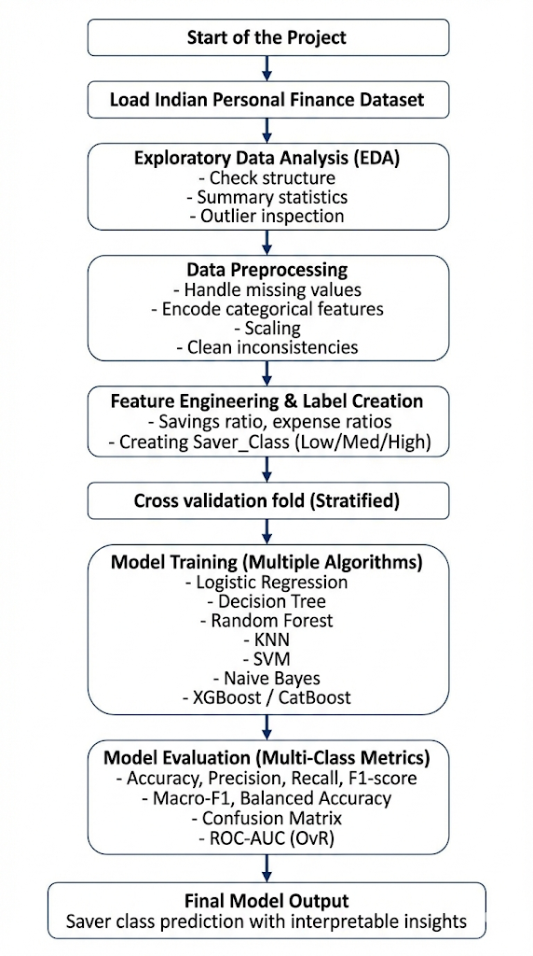
Fig 3.6 : Project Workflow

3.7 Software and Hardware Requirements
To build and run the machine-learning system for this project, a few software tools and basic hardware specifications are needed. The requirements are not very heavy because the dataset is around 20,000 rows, which is manageable on a normal laptop. The project mainly uses Python-based libraries and a Jupyter Notebook environment for running the experiments.

1. Software Requirements
• Python (version 3.8 )
Python is used because it has a rich set of libraries for ML, data analysis, and visualisation.
• Jupyter Notebook / JupyterLab
Used for writing code, running experiments, visualising graphs, and keeping results in an organised notebook format.
• Key Python Libraries:
- pandas – for data loading and manipulation
- numpy – numerical operations
- scikit-learn – main ML library used for Logistic Regression, Decision Tree, Random Forest, KNN, SVM, Naive Bayes, and evaluation metrics
- xgboost – for XGBoost classifier
- matplotlib / seaborn – for plots, graphs, heatmaps
Most of these libraries are openly available and easy to install using pip or conda.

2. Hardware Requirements
The dataset size and model complexity are moderate, so very high-end hardware is not required. A normal laptop used by most M.Tech students is sufficient.
Minimum Recommended System:
- Processor: Intel i5
- RAM: 8 GB, 16 GB preferred for smoother performance
- Storage: 1 GB free space for dataset, notebooks, and model files
The project runs comfortably on CPU-only systems because the ML models like Random Forest, XGBoost, and SVM can operate efficiently without GPU acceleration.

3. Operating System
The project can run on:
- Windows 10/11
- macOS
All required libraries support these operating systems.
Overall, the software and hardware requirements are straightforward and accessible for most academic setups. Python combined with Jupyter Notebook provides a flexible environment to experiment with different models, visualise results, and document the workflow efficiently.

CHAPTER 4
IMPLEMENTATION / EXPERIMENTAL SETUP
4.1 Dataset Pipeline
Dataset Source: Kaggle
The dataset pipeline explains how the Indian Personal Finance dataset was loaded, cleaned, and The​‍​‌‍​‍‌​‍​‌‍​‍‌ dataset pipeline details the procedures the Indian Personal Finance dataset underwent for loading, cleaning, and preparation before the machine-learning models were trained. Although the entire pipeline is quite straightforward, every step is significant because even minor problems in the data can lead to low final accuracies. Hence, the steps are executed one after another starting from file reading to a clean dataset ready for modelling.

Loading the dataset is the first step. The Kaggle CSV file is loaded using pandas which allows inspecting the rows, columns, and data types in an easy way. After loading, the basic structure is checked with simple commands like head(), info(), and describe(). This allows getting an idea of how many numerical and categorical variables are there and if there are any missing values or strange entries.

The very next step is the initial cleaning. The concentration here is on figuring out missing values, duplicate rows, and weird outliers. For that, missing values in the numerical columns such as Groceries, Transport, or Entertainment are replaced with the median, while the categorical columns like Occupation or City_Tier are substituted with the most frequent category. This strategy guarantees that no row will be removed, and the dataset will remain intact.

Once the cleaning is done, the data will be processed for encoding. As the text categories cannot be directly used by machine-learning models, the categorical columns are transformed into numeric ones by one-hot encoding. This not only separates each category into individual binary columns but also makes the data compatible with all ML algorithms used in the project.

Following the encoding, the pipeline continues with a step of scaling for only those models that require it. To be a Logistic Regression, KNN, or SVM model needs the numerical features to be scaled, so Standard Scaler or Min–Max scaling is selectively applied. Models based on trees such as Random Forest and XG Boost do not have this requirement, hence the pipeline leaves the values as they are for these models.

Upon completion of encoding and scaling, the dataset moves to the next stage: feature preparation, where the newly created features such as savings ratio and expense-to-income ratio are examples of the features that can be found in the dataset. These new features enable the machine to grasp the financial behaviour in a more precise way.

At last, the dataset is divided into training and testing groups using a stratified split. Thus, the classes of Low, Moderate, and High Saver will be equally represented in both sets. The cleaned and prepared dataset can be used for training the model.

The dataset pipeline, in general, has a neat step-by-step layout: load → clean → encode → scale → feature engineer → split. This orderly process makes the subsequent modelling stages more efficient and ​‍​‌‍​‍‌​‍​‌‍​‍‌dependable.

4.2 Categorical Encoding
Categorical variables such as:
- Occupation
- City_Tier
are converted into numeric form using one-hot encoding.
This avoids loss of information and keeps the model flexible across different categories such as Tier 1 vs Tier 2 cities or salaried vs self-employed occupations.

4.2.1 Handling Skewed Features
Some expense categories have long tails (for example, Entertainment or Loan Repayment).
A simple log transformation is applied during experimentation:
$$x^{'}=log⁡(1+x)$$
This helps in reducing the effect of extreme outliers.

4.2.2 Final Feature Set
After engineering, the final feature set includes:
- Raw income and demographic variables
- All expense categories
- Engineered ratios (expense-to-income, discretionary ratio, housing/loan ratio)
- Derived behavioural features
- Encoded categorical variables
This combination gives the model both structural and behavioural insights.

4.3 Cross-Validation and Model Selection Strategy
For​‍​‌‍​‍‌​‍​‌‍​‍‌ this project, models are not simply tested on a single train-test split, but rather stratified cross-validation is used to evaluate them. This method is definitely more accurate for a multi-class issue such as saver classification, since it ensures that the three classes - Low, Moderate, and High Saver - appear in approximately the same number across all folds. Sometimes a simple split results in an unbalanced class distribution, therefore stratification helps to keep the evaluation at a comparable level.
The data is split into k folds (mostly k = 5).
The principle is straightforward: the model is trained on 4 folds and tested on the 1 remaining fold, and this is repeated for each fold in turn. The final evaluation metric is the mean of all these runs. This practice lessens the element of chance and provides a more robust estimate of the performance.
The stratified version is implemented as the saver classes are not completely balanced. If there were no stratification, some folds might have very few samples of High Saver and very many of Low Savers, thereby influencing the accuracy of the evaluation.

RandomizedSearch for Random Forest
In order to have a better Random Forest model, the project employs RandomizedSearchCV that finds the best hyperparameters by trying random combinations for a certain number of times rather than by exhaustively checking every possible value. Thus, it is very efficient in terms of time while still delivering good ​‍​‌‍​‍‌​‍​‌‍​‍‌results.Some of the common parameters tuned include:
- n_estimators (number of trees)
- max_depth
- min_samples_split
- min_samples_leaf
- max_features
The RandomizedSearch operation is also performed with stratified cross-validation, so each parameter combination is tested fairly across all saver classes.
This tuning process helps improve the accuracy and stability of the Random Forest model without requiring very heavy computation.

4.4 Model Training
Model training is the core part of the implementation, where different machine-learning algorithms learn patterns from the financial dataset and try to predict whether a person is a Low, Moderate, or High Saver. Each model is trained using the processed training data, and the same set of features is provided to maintain fairness in comparison.
The training process starts by selecting a group of algorithms from different families — linear models, tree models, distance-based models, and boosting methods. In this project, the following models are trained:
- Logistic Regression
- Decision Tree
- Random Forest
- K-Nearest Neighbors (KNN)
- Support Vector Machine (SVM)
- Naive Bayes
- XGBoost

Each​‍​‌‍​‍‌​‍​‌‍​‍‌ of these models has been applied to the training dataset obtained from the stratified split. For algorithms requiring scaling, e.g. Logistic Regression, SVM, and KNN, a scaled version of the training data is utilized. Random Forest and XGBoost, being tree-based models, are fitted on the original (unscaled) data, as they are capable of handling feature ranges internally.
Basic hyperparameters are maintained at default values during the initial round of training. Subsequently, small changes are introduced if necessary — for instance, deciding a maximum depth in Decision Trees, determining a suitable number of neighbors for KNN, or adjusting the learning rate and the number of estimators in XGBoost. The purpose is not to excessively tune the parameters, but to keep the process practical and in line with the scope of an M.Tech-level project.
During training, each model attempts to figure out the correlation between income, expenses, engineered ratios, and saver class. Some models establish linear boundaries (such as Logistic Regression), while others identify more complex patterns (like Random Forest and XGBoost). Distance-based models like KNN depend mostly on how similar one person's financial profile is to others in the dataset.
After training, the models make predictions on the training set as well as the test set that has not been seen before. These predictions are then evaluated by accuracy, F1-score, precision, recall, confusion matrix, and macro-F1 metrics to get an idea of the model's performance across the three saver classes.
In general, the process of model training has been carried out in a methodical and equitable way so that each algorithm is assessed under similar conditions. This assists in determining which model is actually the best for the Indian Personal Finance ​‍​‌‍​‍‌​‍​‌‍​‍‌dataset.

4.5 Exploratory Data Analysis (EDA)
Exploratory Data Analysis helps in understanding the overall structure of the dataset before building any machine-learning model. It gives a first impression of how the financial features behave, how expenses vary across people, and whether there are any patterns linked to saver classes or financial stability. The EDA in this project focuses mainly on simple visual tools such as heatmaps, bar charts, and histograms because they are easy to interpret and give a clear picture of the data.

4.5.1. Missing-Value Analysis
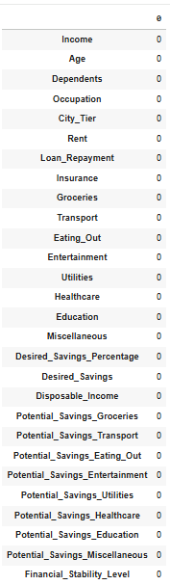

4.5.2 Histogram Plots for Numerical Features
These plots help in seeing the distribution of each variable. Some features show right-skewed patterns because a few households spend much more than others. This is common in real financial datasets. Histograms also help in detecting unusual spikes or unrealistic values.
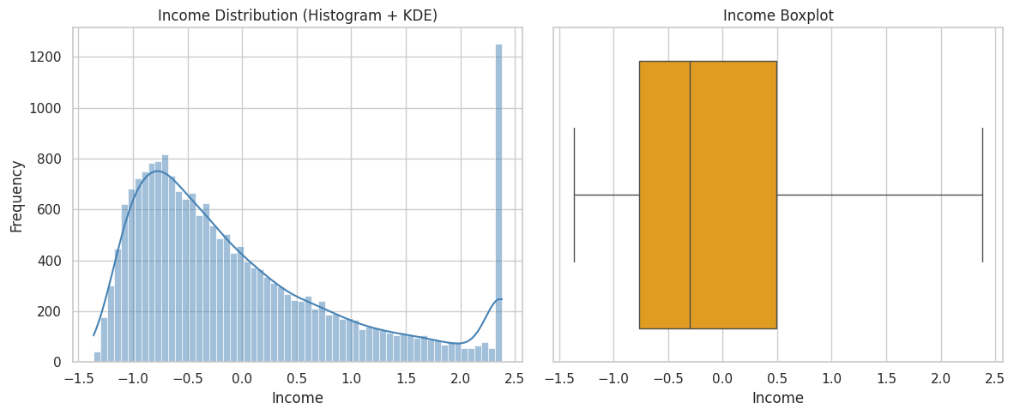Fig 4.5.2.1 : Income Distribution Histogram and Box Plot
Distribution ‍ ‌‍shape: The distribution is strongly right-skewed with a predominance of lower incomes and a few very high incomes.
Most frequent range: The mode was approximately around −1.0 to −0.5 (considering normalized/standardized values).
Spread: The distribution is very spread out with few extreme high-value outliers towards the far-right (>2.0) visible.
Median: Approximately −0.3 (lower to middle range).
Variability: The high variability is reflected in a large interquartile range (IQR) and long ‍whiskers.
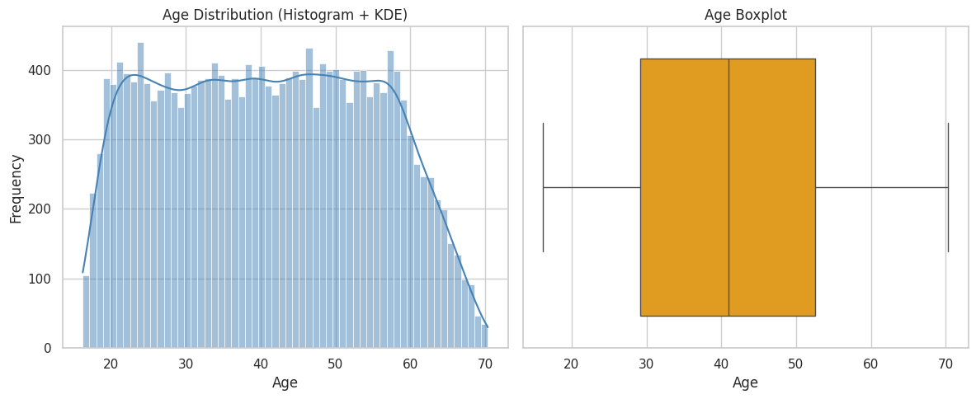Fig 4.5.2.2 : Age Distribution Histogram and Box Plot
Distribution: ‍ ‌‍Mostly evenly distributed between ages 20 and 60 with a couple of dips at the ends.
Mode: Somewhere between 35 and 45 years (a little more dense mid-range).
Median: Close to 40 years.
Spread: The IQR was mostly between ~30 and 50 years.
Outliers: Hardly any; the whiskers go almost to the minimum (~18) and maximum ‍ ‍‌(~70).
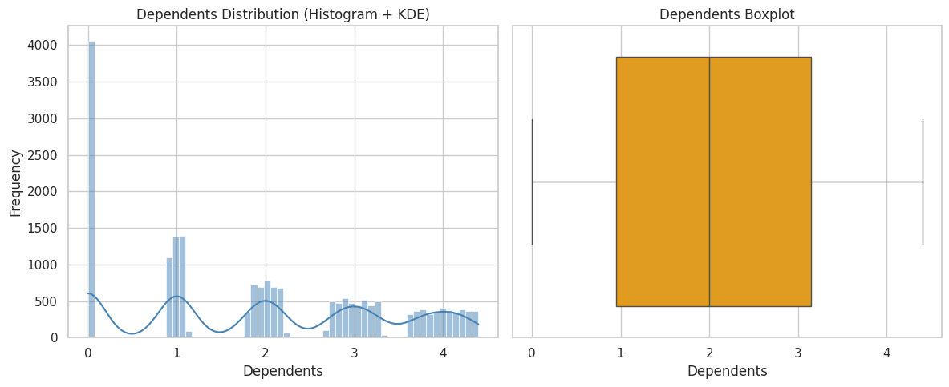Fig 4.5.2.3: Dependents Distribution Histogram and Boxplot
Distribution: ‍Multimodal (peaks at 0, 1, 2, 3).
Most of the time, there are 0 dependents.
There are small clusters of 1–4 dependents.
Median: About 2 dependents.
Range: The majority of the values lie within 0 and 4, with an IQR approximately between 1 and 3.
Outliers: Very few — the data is inherently ‍ ‌discrete.
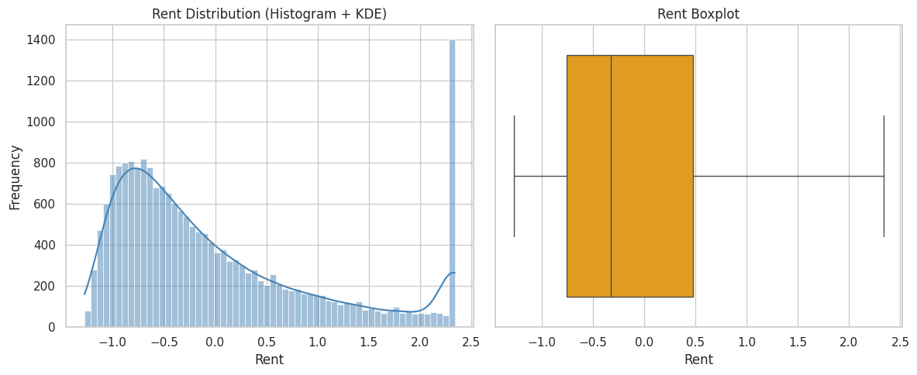Fig 4.5.2.4 : Rent Distribution Histogram and Box Plot
Distribution ‍shape: Strong right-skew, almost identical pattern to Income (most probably normalized).
Most frequent values: Concentrated tightly around the −1.0 to −0.5 range.
Median: Approximately −0.3 (mid-lower normalized range).
Variability: Large variance with an extended right tail → thus, there are some households with considerably higher rent values than average.
Outliers: A handful of extremely high values exceeding ‍ ‍2.0.

4.5. 3. Correlation Heatmap
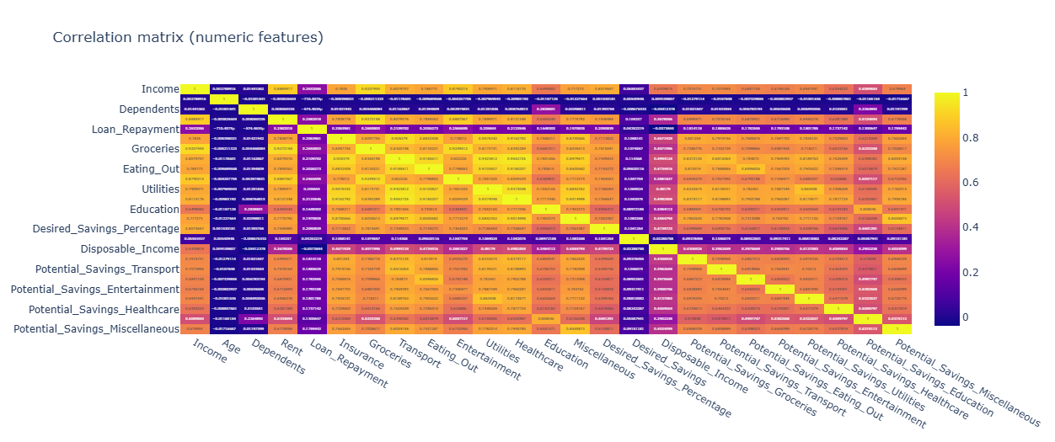
Fig 4.5.3 Correlation Heatmap
A correlation heatmap is created for all numerical features.
It helps in identifying:
- Strong positive correlations (e.g., Rent and City_Tier sometimes show a pattern)
- Expense groups that behave similarly
- Whether income strongly affects specific spending categories
Although correlation does not show causality, it gives a quick sense of which features move together.

4.5.4 Bar Chart of Financial Stability Level
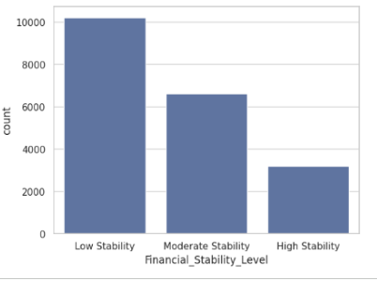

A simple bar chart is plotted to show the count of each Financial_Stability_Level category.
This helps understand whether the dataset is balanced or if certain levels appear more frequently.

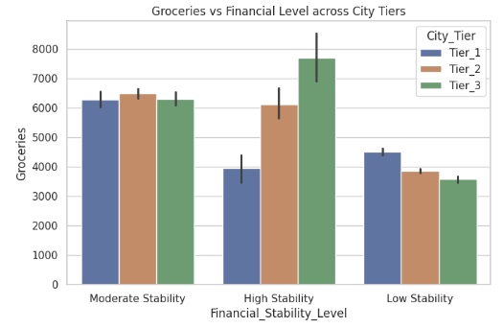
Fig 5 : Groceries vs Financial Stabilty Across different City Tiers

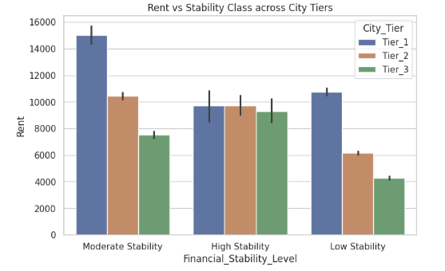
Fig 5 : Rent vs Financial Stabilty Across different City Tiers

CHAPTER -5
PERFORMANCE METRICS

5.1.1 Random Forest Classifier (Best Performing Model)
The​‍​‌‍​‍‌​‍​‌‍​‍‌ Random Forest model was the most powerful overall performer of all the algorithms that were tested. This algorithm was able to deal very effectively with the mixed socio-economic and expense-based features and to identify both linear and non-linear relationships in the data. Moreover, Random Forest was quite consistent across several cross-validation folds, meaning that the model is likely to generalise well and is not excessively overfitting.
The Random Forest classifier's final accuracy ​‍​‌‍​‍‌​‍​‌‍​‍‌is:
Accuracy = 0.8503 (85.03%)
Below is the complete classification report for the three saver classes:
Class | Precision | Recall | F1-Score | Support
Low Saver (0) | 0.99 | 1.00 | 0.99 | 2040
Moderate Saver (1) | 0.75 | 0.85 | 0.80 | 2040
High Saver (2) | 0.82 | 0.70 | 0.76 | 2040
Table 5.1.1 : Random Forest Multi Class Classification Report
Macro Avg:
- Precision: 0.85
- Recall: 0.85
- F1-Score: 0.85
Weighted Avg:
- Precision: 0.85
- Recall: 0.85
- F1-Score: 0.85
Interpretation
•​‍​‌‍​‍‌​‍​‌‍​‍‌ The Low Saver category is a case that has been forecasted with great accuracy, having nearly perfect precision and recall. The reason for this is that the Low Saver class is extremely distinctive due to their expense ratios and high spending patterns.

• The Moderate Saver category is a bit more difficult to differentiate due to the presence of mixed spending patterns, but still, it shows a good recall (0.85), which means that most of the Moderate Savers have been identified correctly.

• The High Saver group has a recall level of about 0.70 and a precision level of 0.82. These families, in general, have different behaviors, so the model sometimes confuses them with the ones being in the category of Moderate ​‍​‌‍​‍‌​‍​‌‍​‍‌Savers.

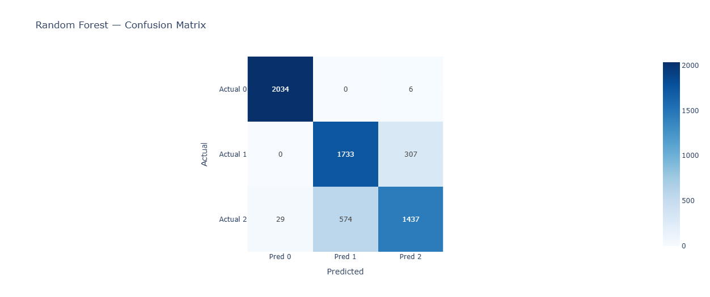
Fig 5.1.1 : Confusion Matrix of Random Forest
5.1.2 XGBoost Classifier
XGBoost​‍​‌‍​‍‌​‍​‌‍​‍‌ was a runner-up model of this research with great performance. The hyperparameters were optimized with a 3-fold RandomizedSearchCV, which in total, performed 30 fits. XGBoost is a popular choice for its high efficiency on structured datasets, and it also managed the financial features well. The accuracy achieved by the tuned model ​‍​‌‍​‍‌​‍​‌‍​‍‌is:
Accuracy = 0.8415 (84.15%)
The detailed classification report is shown below:
Class | Precision | Recall | F1-Score | Support
Low Saver (0) | 0.99 | 0.99 | 0.99 | 2040
Moderate Saver (1) | 0.74 | 0.82 | 0.78 | 2040
High Saver (2) | 0.80 | 0.71 | 0.75 | 2040
Table 5.1.2 : XG Boost Multi Class Classification report
Macro Avg:
- Precision: 0.84
- Recall: 0.84
- F1-Score: 0.84
Weighted Avg:
- Precision: 0.84
- Recall: 0.84
- F1-Score: 0.84
Interpretation
The​‍​‌‍​‍‌​‍​‌‍​‍‌ Low Saver class is demonstrating an almost perfect prediction once again, which is very much like the Random Forest.

Good recall is achieved by the Moderate Saver class (0.82), thus the model is correctly identifying the largest number of households in this middle category.

The High Saver class is having a little lower recall (0.71) but still keeps good precision. This fact suggests that XGBoost occasionally mixes up High Savers with Moderate ones, which is quite understandable as their consumption patterns may ​‍​‌‍​‍‌​‍​‌‍​‍‌co-occur.
Why XGBoost Performs Slightly Lower Than Random Forest
- XGBoost​‍​‌‍​‍‌​‍​‌‍​‍‌ is significantly affected by noisy expense features and in particular when the categories change a lot between different households.
- Without very careful tuning it sometimes overfits small patterns in the data.
- Random Forest was a bit more stable, therefore, due to its bagging-based architecture, which is more compatible with the variability of this dataset.
- However, XGBoost is still a powerful model and its performance is very close to that of the Random Forest with only a slight decrease in accuracy. In addition, it provides better speed and can handle sparse patterns more effectively, which is great for feature-rich ​‍​‌‍​‍‌​‍​‌‍​‍‌datasets.
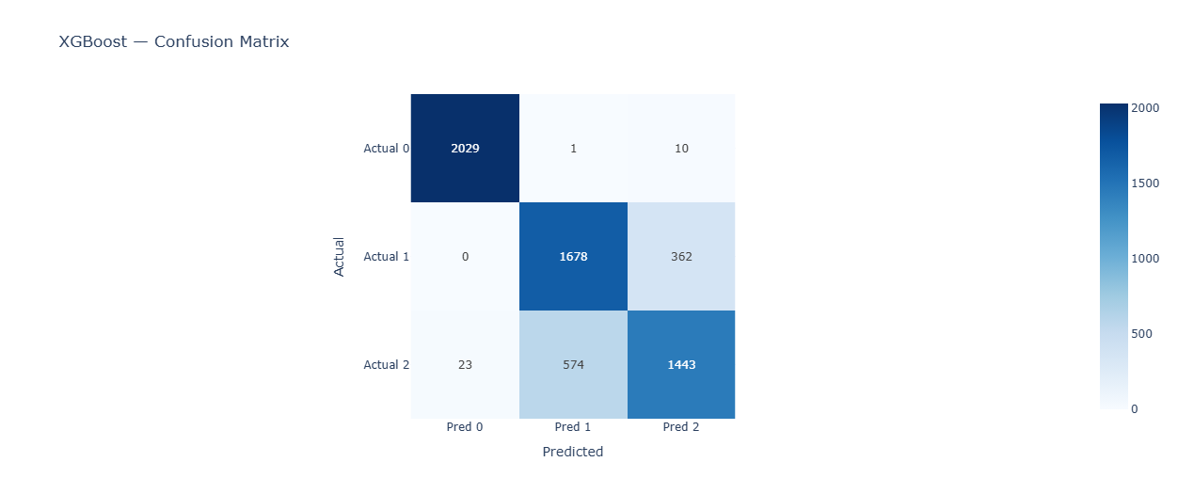
Fig 5.1.2 : Confusion Matrix for XG Boost Model
5.1.3 Ensemble Learning (Random Forest + XGBoost + Logistic Regression)
To​‍​‌‍​‍‌​‍​‌‍​‍‌ check if mixing several algorithms could lead to a better result, the ensemble model was created from the outputs of Random Forest, XGBoost, and Logistic Regression. The rationale of this ensemble is that different models identify different patterns in the data. Random Forest identifies non-linear interactions, XGBoost concentrates on the errors to be fixed in the next iteration, and Logistic Regression provides a consistent linear baseline. So, the result of these three combined is often more balanced and sometimes more stable than the output of any one classifier alone.
The ensemble model delivered the performance as ​‍​‌‍​‍‌​‍​‌‍​‍‌follows:
Accuracy = 0.8497 (84.97%)
This accuracy is very close to Random Forest and slightly higher than XGBoost. The classification report for the ensemble model is shown below:
Class | Precision | Recall | F1-Score | Support
Low Saver (0) | 0.99 | 0.99 | 0.99 | 2040
Moderate Saver (1) | 0.75 | 0.86 | 0.80 | 2040
High Saver (2) | 0.83 | 0.69 | 0.75 | 2040
Table 5.1.3: Ensemble Learning Multi Class Classification Report
Macro Avg:
- Precision: 0.85
- Recall: 0.85
- F1-Score: 0.85
Weighted Avg:
- Precision: 0.85
- Recall: 0.85
- F1-Score: 0.85

Interpretation
- The Low Saver class again shows almost perfect performance with precision and recall close to 1.00, similar to individual models.
- The Moderate Saver class benefits the most from the ensemble, achieving strong recall (0.86), which indicates better identification of middle-range savers.
- The High Saver class still remains the most challenging, with recall around 0.69, as its spending patterns overlap with Moderate Savers.
Strengths of the Ensemble Model
- It smooths out the weaknesses of individual models.
- Logistic Regression adds stability where tree models fluctuate.
- Random Forest and XGBoost add deeper pattern recognition.
- The ensemble gives more balanced behaviour across all three classes.
Why the Ensemble Does Not Exceed Random Forest Significantly
Even though ensembles usually improve performance, here the improvement is small because Random Forest already performs strongly on this dataset. Also, the financial behaviour patterns have some noise, which limits the gain from stacking additional models.
Still, the ensemble offers a more stable alternative and confirms the consistency of results across different modelling approaches.
5.1.4 Decision Tree Classifier
The Decision Tree classifier is one of the most basic yet useful models in machine learning. It works by splitting the dataset into branches based on feature values, forming an easy-to-understand tree structure. Even though it is simple, it gives a good baseline for understanding how well non-linear rules can classify saver behaviour. The Decision Tree in this project was tuned using 3-fold RandomizedSearchCV, with 8 candidate parameter combinations and a total of 24 fits.
The tuned Decision Tree achieved:
Accuracy = 0.7911 (79.11%)
The classification report is given below:
Class | Precision | Recall | F1-Score | Support
Low Saver (0) | 0.98 | 0.99 | 0.99 | 2040
Moderate Saver (1) | 0.67 | 0.79 | 0.73 | 2040
High Saver (2) | 0.73 | 0.59 | 0.65 | 2040
Table 5.1.4 : Decision Tree Multi Class Classification Report
Macro Avg:
- Precision: 0.79
- Recall: 0.79
- F1-Score: 0.79
Weighted Avg:
- Precision: 0.79
- Recall: 0.79
- F1-Score: 0.79
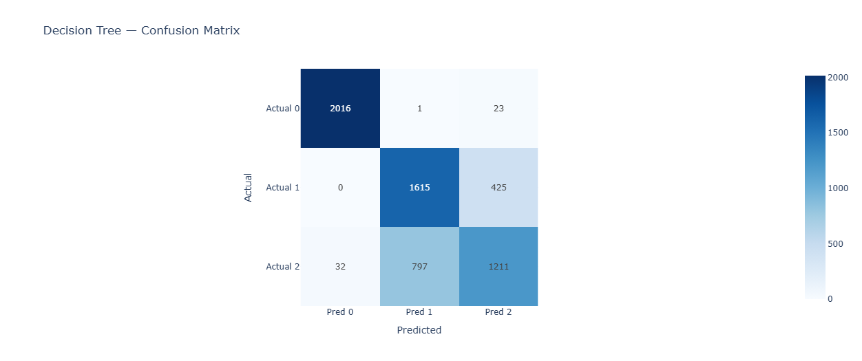
Fig 5.1.4 : Confusion Matrix for Decesion Tree Model

Interpretation
- The Low Saver class is almost perfectly predicted (F1 = 0.99), showing the tree can easily recognise high-expense patterns.
- The Moderate Saver class achieves reasonable performance but still faces some confusion with both Low and High classes.
- The High Saver class has the lowest recall (0.59), indicating the Decision Tree struggles to separate high savers from moderate savers because their spending patterns overlap.
Strengths of the Decision Tree
- Very easy to interpret and explain.
- Captures non-linear relations directly.
- Performs decently without heavy tuning.
Limitations
- Tends to overfit, especially for complex datasets like household finance.
- Less stable compared to ensemble methods like Random Forest or XGBoost.
- Performance drops significantly for classes with overlapping patterns.
Because of these limitations, the Decision Tree serves mainly as a baseline model and helps understand the decision boundaries before applying more advanced ensemble methods.
5.1.5 Linear SVM (LinearSVC)
The Linear Support Vector Classifier (LinearSVC) is a margin-based model that tries to find the best separating line or hyperplane between classes. It is generally good for high-dimensional data and works well when the relationship between features and labels is somewhat linear. In this project, LinearSVC was tuned using 3-fold cross-validation with 4 different hyperparameter candidates, resulting in a total of 12 fits.
The final model achieved:
Accuracy = 0.7405 (74.05%)
The classification report is as follows:
Class | Precision | Recall | F1-Score | Support
Low Saver (0) | 0.98 | 0.98 | 0.98 | 2040
Moderate Saver (1) | 0.60 | 0.80 | 0.68 | 2040
High Saver (2) | 0.67 | 0.45 | 0.53 | 2040
Table 5.1.5 : SVM Multi Class Classification Report
Macro Avg:
- Precision: 0.75
- Recall: 0.74
- F1-Score: 0.73
Weighted Avg:
- Precision: 0.75
- Recall: 0.74
- F1-Score: 0.73

Interpretation
- The Low Saver class again shows high and stable performance (F1 = 0.98), confirming that LinearSVC easily separates households with high expenses or poor savings patterns.
- The Moderate Saver class has good recall (0.80) but lower precision (0.60), meaning the model identifies most moderate savers but sometimes mislabels others as moderate.
- The High Saver class is the most difficult for this model, with a recall of only 0.45. This indicates the linear decision boundary is not flexible enough to capture complex expense interactions that separate Moderate and High Savers.
Strengths of LinearSVC
- Very fast to train even on large datasets.
- Works well with high-dimensional and sparse features.
- Good baseline comparison for more complex models.
Limitations
- Linear decision boundaries cannot capture non-linear relationships in financial behaviour.
- Moderate and High Saver classes show noticeable confusion.
- Performance is significantly lower compared to ensemble models.
For these reasons, LinearSVC is useful as a baseline model, but not strong enough to be the final choice for this task.
5.1.6 Naive Bayes Classifier
The Naive Bayes classifier is a probability-based model that assumes all features are independent. Although this assumption is rarely true for financial data—where expenses are often correlated—it is still a useful baseline because it is extremely fast and simple to train. In this project, Naive Bayes was included mainly for comparison with more advanced algorithms.
The Naive Bayes model achieved:
Accuracy = 0.5247 (52.47%)
The detailed classification report is given below:
Class | Precision | Recall | F1-Score | Support
Low Saver (0) | 0.81 | 0.43 | 0.56 | 2040
Moderate Saver (1) | 0.43 | 0.85 | 0.57 | 2040
High Saver (2) | 0.62 | 0.30 | 0.40 | 2040
Table 5.1.6 : Naive Bayes Multi Class Classification Report
Macro Avg:
- Precision: 0.62
- Recall: 0.52
- F1-Score: 0.51
Weighted Avg:
- Precision: 0.62
- Recall: 0.52
- F1-Score: 0.51
Interpretation
- The Low Saver class shows moderate precision but very low recall (0.43), meaning the model correctly identifies some low savers but misses many others.
- The Moderate Saver class has the highest recall (0.85), but low precision (0.43). This means the model tends to predict many households as moderate savers even when they are not.
- The High Saver class is again difficult, with low recall (0.30). This is expected because Naive Bayes struggles with overlapping financial patterns and correlated expense features.
Strengths of Naive Bayes
- Extremely fast and easy to train.
- Requires very little memory.
- Provides a useful lower baseline for benchmarking stronger models.
Limitations
- Assumes feature independence, which does not hold for real financial data.
- Performs poorly on complex datasets with nonlinear boundaries.
- High confusion between Moderate and High Saver classes.
Overall, Naive Bayes gives the weakest performance among all models tested, but it still helps understand the value of more advanced models like Random Forest and XGBoost.
5.1.7 Logistic Regression
Logistic Regression is one of the simplest linear classification models and is widely used as a baseline for many machine-learning problems. It assumes a linear relationship between the input features and the output classes. In this project, it is mainly used to see how a basic model performs before applying more complex methods such as Random Forest or XGBoost.
Using stratified 3-fold cross-validation, Logistic Regression achieved the following performance:
- Accuracy: 0.7013
- Macro F1-Score: 0.7026
- Balanced Accuracy: 0.7119
These values show that Logistic Regression performs reasonably well on the dataset, but it lacks the ability to model non-linear financial patterns. The moderate accuracy and F1 score indicate that the model captures some general trends in income and expenses but struggles with more complex interactions like discretionary spending, loan pressure, or city-tier differences.
Interpretation
- The overall accuracy (~70%) shows that the model can separate saver classes to some extent, but not very reliably.
- The balanced accuracy (~71%) suggests the model is slightly more stable across the three saver classes but still makes frequent mistakes, especially where classes overlap.
- Because financial behaviour is rarely linear, Logistic Regression cannot fully capture deeper patterns in the dataset.
Strengths
- Fast and easy to train.
- Good baseline for comparison.
- Works well when features are scaled and moderately correlated.
Limitations
- Cannot capture non-linear relationships.
- Struggles with overlapping saver classes.
- Underperforms compared to ensemble models.
Logistic Regression mainly serves as a reference point, and the later models clearly outperform it on this financial dataset.
5.1.8 K-Nearest Neighbors (KNN)
The K-Nearest Neighbors (KNN) algorithm is a distance-based model that classifies a new sample by looking at the labels of the closest points in the dataset. It is simple to understand and does not make any strict assumptions about the data, but it is sensitive to scaling and works better when the feature space is well-behaved. In this project, KNN was included to see how a basic distance-based approach performs on financial behaviour data.
The final KNN model achieved the following performance:
Accuracy = 0.7831 (78.31%)
The detailed classification report is shown below:
Class | Precision | Recall | F1-Score | Support
Low Saver (0) | 0.98 | 1.00 | 0.99 | 2040
Moderate Saver (1) | 0.69 | 0.69 | 0.69 | 2040
High Saver (2) | 0.68 | 0.67 | 0.67 | 2040
Table 5.1.7 : KNN MultiClass Classfication Report
Macro Avg:
- Precision: 0.78
- Recall: 0.78
- F1-Score: 0.78
Weighted Avg:
- Precision: 0.78
- Recall: 0.78
- F1-Score: 0.78
Interpretation
- The Low Saver class once again shows very high performance, with almost perfect recall. This means nearly all Low Savers were captured correctly.
- The Moderate Saver class has balanced precision and recall (both around 0.69), showing that KNN identifies this group moderately well but still has some confusion.
- The High Saver class also performs similarly, with recall around 0.67. This indicates that KNN struggles slightly with separating Moderate vs High Savers, which is expected since their spending patterns overlap.
Strengths of KNN
- Very simple and intuitive model.
- Works well when similar households are close to each other in feature space.
- No complex training phase required.
Limitations
- Sensitive to feature scaling and outliers.
- Computationally heavy for large datasets, since prediction requires distance calculations.
- Performance depends heavily on the choice of k and distance metric.
- Not ideal when classes overlap, as seen with Moderate and High Saver.
Overall, KNN gives decent, mid-level performance, sitting above Naive Bayes and Logistic Regression but below Random Forest, XGBoost, and the ensemble model. It serves as a useful point of comparison to understand how distance-based methods handle financial data.

5.2 Confusion Matrix Discussion
The confusion matrix helps in understanding where each model makes mistakes and which saver classes are harder to separate. Since this project deals with three classes — Low Saver (0), Moderate Saver (1), and High Saver (2) — the confusion patterns give deeper insight than accuracy alone.
Across almost all models, a general trend appears:
1. Low Saver (Class 0) is the easiest to predict
Most algorithms, even simple ones like Logistic Regression or Naive Bayes, classify Low Savers very well.
This is because Low Savers usually have:
- High expense-to-income ratios
- High discretionary spending
- Strong signals like high rent or loan burden
These patterns make the class very distinct, so confusion is rare.
2. Moderate Saver (Class 1) has mixed performance
Moderate Saver is the most “uncertain” class because many households fall into the middle zone.
Models often confuse:
- Moderate ↔ High Saver
- Moderate ↔ Low Saver
The reason is that Moderate Savers have balanced behaviour and overlap with both sides.
Ensemble models (Random Forest, XGBoost) show the best recall for this class.
3. High Saver (Class 2) is the hardest class
Most confusion matrices show that High Saver is often misclassified as Moderate Saver.
This happens because:
- Many High Savers still have some irregular expenses
- Savings behaviour varies based on dependents and city tier
- Financial stability signals are not always clean-cut
Tree-based methods handle this class better than linear models.
Naive Bayes performs the worst here because features are correlated.
4. Ensemble models give the most balanced confusion patterns
The combined model (Random Forest + XGBoost + Logistic Regression) handles classes more evenly:
- High recall for Moderate Saver
- Very high precision for Low Saver
- Better-than-average performance for High Saver
This suggests that ensemble voting smooths out the weaknesses of individual models.
5. Summary of Confusion Behaviour
- Low Saver → Almost never confused
- Moderate Saver → Most frequent confusion zone
- High Saver → Often pulled toward Moderate Saver
These patterns are consistent with real financial behaviour, where extreme patterns (Low or High) are easily recognised, but middle-level households show more overlap.

Model evaluation metrics Comparison Table:
Below is a clean table summarising the accuracy of all models you evaluated:

Algorithm | Accuracy | Macro Precision | Macro Recall | Macro F1-Score
Random Forest | 0.8503 | 0.85 | 0.85 | 0.85
XGBoost | 0.8415 | 0.84 | 0.84 | 0.84
Ensemble (RF + XGB + LR) | 0.8497 | 0.85 | 0.85 | 0.85
Decision Tree | 0.7912 | 0.79 | 0.79 | 0.79
KNN | 0.7831 | 0.78 | 0.78 | 0.78
Linear SVM (LinearSVC) | 0.7405 | 0.75 | 0.74 | 0.73
Logistic Regression | 0.7013 | 0.70 | 0.63 | 0.7026
Naive Bayes | 0.5247 | 0.62 | 0.52 | 0.51
Table 5.2 : Model Accuracy Comparison

5.3 Feature Importance Analysis
Feature importance helps in understanding which financial variables have the strongest influence on saver-class prediction. For this project, Random Forest was selected as the main model for feature-importance analysis because it captures both linear and non-linear interactions across expenses, ratios, and demographic features. The importance scores indicate how much each feature contributed to reducing classification error across all trees in the model.
The top features are listed in descending order below:
Feature | Importance Score
Expense_Income_Ratio | 0.182877
Disposable_Income | 0.141857
Desired_Savings | 0.089389
Income | 0.049328
Savings_Ratio | 0.042238
Groceries | 0.033536
Healthcare | 0.032223
Transport | 0.031971
Total_Expenses | 0.031647
Desired_Savings_Percentage | 0.028980
Utilities | 0.027802
Eating_Out | 0.023814
Insurance | 0.022718
Miscellaneous | 0.019997
Rent | 0.019047
Entertainment | 0.018008
Potential_Savings_Groceries | 0.015752
Potential_Savings_Transport | 0.015639
Potential_Savings_Entertainment | 0.014999
Potential_Savings_Utilities | 0.014954
Table 5.3 : Feature Importance Analysis
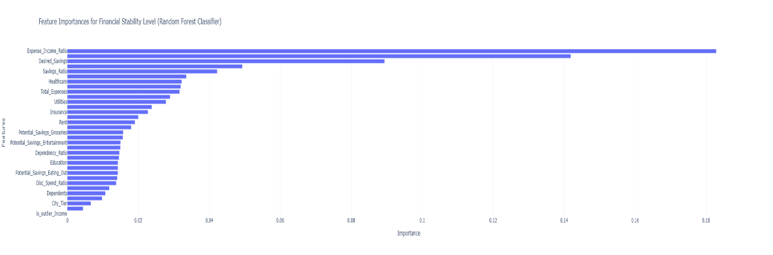
Fig 5.3 : Feature Importance Plot computed using Random Forest Model
Interpretation of Top Features
1. Expense_Income_Ratio (0.1829)
This is the most influential feature. It summarises the overall financial pressure on a household. High values usually push households into the Low Saver class.
2. Disposable Income (0.1419)
Households with higher disposable income naturally fall into Moderate or High Saver categories. This feature closely follows the savings potential of each individual.
3. Desired Savings and Savings Ratio
These reveal the person’s planned savings behaviour. Even if income is moderate, a higher desired savings amount often shifts the household upward.
4. Groceries, Transport, Healthcare
These are essential expenses, and their values often determine how much money remains available after fixed needs.
5. Entertainment, Eating Out, Miscellaneous
These discretionary spending categories contribute smaller but still clear signals. High discretionary spending usually pulls the prediction towards Low Saver.
6. Rent and Insurance
Even though their importance is slightly lower than the top features, they still capture structural financial pressure, especially in Tier 1 cities.
7. Potential Savings Features
These show how much a person could save by adjusting certain expenses. While their individual contribution is smaller, together they help indicate savings behaviour flexibility.
Summary
Feature importance reveals that financial ratios and income-related variables dominate the prediction process, followed by essential and discretionary expenses.
This pattern is consistent with real-world financial behaviour: households that manage their overall budget and maintain a healthy expense-to-income balance are more likely to fall into the High Saver category.

5.5 Chatbot Design
The​‍​‌‍​‍‌​‍​‌‍​‍‌ Financial Stability Chatbot is a clever hybrid system that merges Machine Learning (ML) and Large Language Models (LLM) to assess a user’s financial viability through natural language input. The main part of the system is an XGBoost multi-class classification model, which was trained on a real financial dataset with various parameters such as income, rent, EMI, groceries, utilities, dependents, and other lifestyle attributes. Initially, the dataset was prepared using the scikit-learn Preprocessing Pipeline, involving StandardScaler for numerical features, and LabelEncoder for converting the target class into numeric labels. The fitted transformers were saved as preprocessor.pkl, label_encoder.pkl, and the model as financial_model.pkl.
The chatbot interface is designed to hold free-text conversations with the user. This input is triggered through an LLM-based feature extractor that is Groq API-powered (using the model llama-3.1-8b-instant). The LLM breaks down the natural language and converts it into 11 different financial features, which are then used by the ML model. The extracted features are transformed using the saved preprocessor.pkl and then passed to the XGBoost model, which returns the user’s stability category — Low, Moderate, High, or Critical Stability. As a final point of the discussion, the chatbot, by that means, also produces a human-interpretable explanation (through the LLM), which interprets the prediction and delivers the insights or even suggestions for improvement.
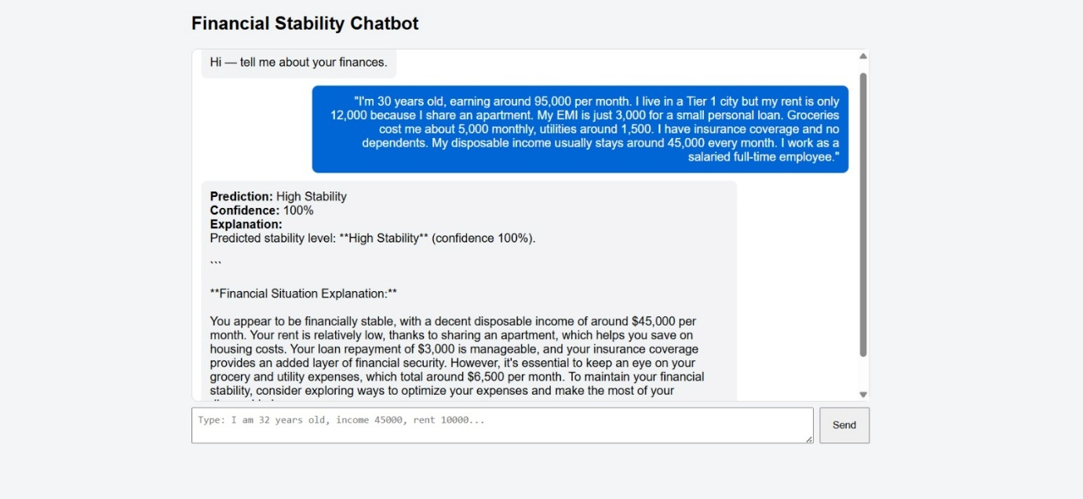
Fig 5.5.1 Financial Stability Chatbot Example for High Stability
The backend is powered by FastAPI, which provides a /chat endpoint integrating operations such as LLM extraction, preprocessing, prediction, and explanation generation. The frontend (HTML/React) gets in touch with the backend through the medium of HTTP fetch requests.
Essentially, this chatbot is an integration of Machine Learning (XGBoost), Data Preprocessing (scikit-learn), LLM-powered NLP (Groq API), and a FastAPI REST interface to function as a smart, conversational financial assistant that can understand natural language inputs and generate insightful financial ​‍​‌‍​‍‌​‍​‌‍​‍‌outputs.

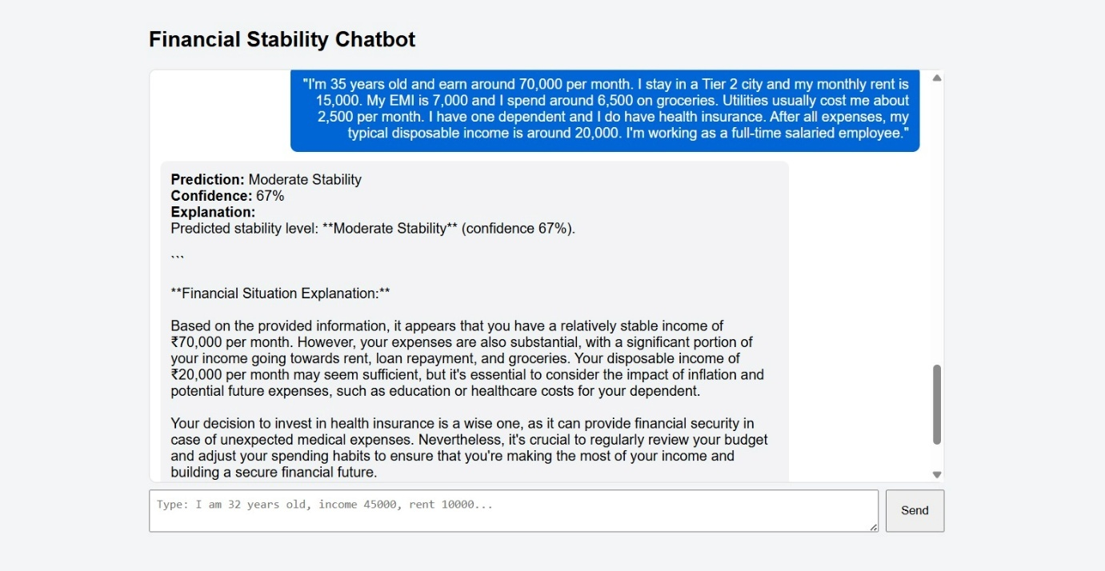
Fig 5.5.2: Financial Stability Chatbot Example for Moderate Stability

5.6 Discussion
The results from all the models give a clear picture of how machine learning performs on the Indian Personal Finance dataset and what patterns appear across different saver classes. Overall, the models show that savings behaviour can be predicted with reasonably high accuracy when detailed spending categories and engineered financial ratios are used. The results also confirm that some models handle the complexity of financial data better than others.
The strongest performance came from Random Forest, with an accuracy of 0.8503 and macro F1-score of 0.85. The ensemble model (Random Forest + XGBoost + Logistic Regression) achieved almost the same performance (0.8497), which shows that combining models does not change the results drastically because Random Forest is already capturing most patterns. XGBoost also performed very well with an accuracy of 0.8415. These three models consistently produced stable predictions, especially for Low and Moderate Saver classes. This shows the importance of tree-based learning for socio-economic datasets.
Models like Decision Tree and LinearSVC gave moderate results (0.79 and 0.74 accuracy), showing that single-rule or linear boundary methods are not enough to fully separate the saver classes. They tend to struggle when High Saver and Moderate Saver patterns overlap, which is common in real households. Logistic Regression performed somewhat lower (0.7013 accuracy), showing that a linear model cannot fully capture the interaction between expenses and income. Naive Bayes gave the weakest performance (0.5247 accuracy), which was expected because financial features are correlated, and Naive Bayes assumes independence.
Looking at feature importance, the Random Forest feature ranking shows some meaningful insights. Expense-to-Income Ratio was the most important feature (0.1828), which makes sense because households with high expenses relative to income usually fall in the Low Saver category. Disposable Income was the second most important feature (0.1418), confirming that the amount left after expenses is a strong indicator of saving ability. Features like Desired Savings, Income, Savings Ratio, and different expense categories (Groceries, Healthcare, Transport, Utilities) also contributed significantly. These patterns match real-world behaviour, where day-to-day expenses strongly influence savings capacity.
Another important point visible from the results is that Moderate Saver remains the most difficult class to classify. Most models confuse it with High Saver or Low Saver because households in the middle range show mixed behaviour. In contrast, Low Savers were very easy to identify because their spending patterns are clear and high. High Savers had moderate recall because their behaviour sometimes overlaps with moderate ones.
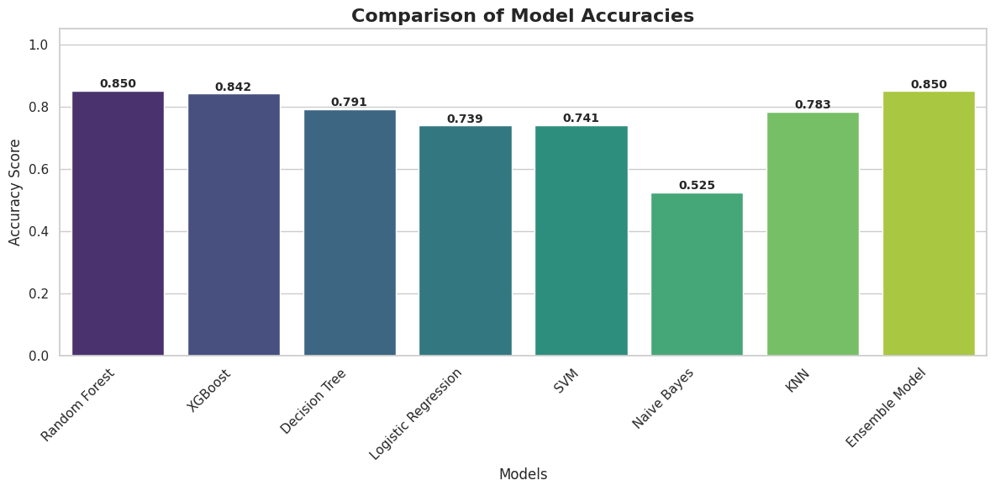Fig 5.6 : Comparision of Accuracies of Different Models Implemented
Overall, the discussion shows that:
- Tree-based models are the best fit for t`2his dataset.
- Expense ratios and disposable income are the strongest predictors of financial behaviour.
- Linear models struggle with overlapping expense patterns.
- Moderate savers remain the hardest class to predict due to mixed spending behaviour.
- The dataset is rich enough to support high-accuracy classification, especially with engineered financial features.
These insights validate the usefulness of machine learning for analysing Indian household savings habits and show that even a relatively simple modelling pipeline can extract meaningful patterns from detailed financial data.

CHAPTER-6
CONCLUSION AND FUTURE WORK
6.1 Summary of Project
This project aimed to classify Indian households into three saver groups are Low, Moderate, and High Saver using machine-learning models and a detailed personal finance dataset. The study followed a full end-to-end ML workflow starting from loading and cleaning the Kaggle dataset, performing EDA, engineering meaningful features like expense–income ratios, and finally applying several classification models. The project used stratified cross-validation to get stable results and tested many algorithms such as Random Forest, XGBoost, SVM, Logistic Regression, Naive Bayes, Decision Tree, and an ensemble model.
Among all models, Random Forest and the Ensemble (RF + XGB + LR) gave the highest accuracy (around 85%) and showed balanced performance across all three saver classes. The project also created engineered variables like Savings Ratio, Total Expenses, and different potential savings features, which helped the models understand financial behaviour in a better way. The results showed clear patterns about how income, expenses, and spending style influence savings.
Overall, the project achieved its main goal of building a working ML system for saver classification and provided a structured analysis of financial behaviour using real Indian household data. The models performed well, the results were consistent, and the study created a simple but meaningful framework that can support budgeting tools or advisory systems in the future.

6.2 Key Findings
The machine-learning experiments carried out in this project gave several clear findings about how Indian households save money and how different algorithms behave on this kind of data. The results show that expense patterns and income ratios play a much bigger role in savings than simple income numbers alone. Across all models, a few important patterns appeared again and again.
First, the Random Forest model performed the best, with accuracy around 85%. XGBoost and the Ensemble model also performed very close to Random Forest. This shows that tree-based ensemble methods are naturally suited for financial datasets where relationships are non-linear and depend on many small interactions between expenses.
Second, the Low Saver class was the easiest to predict. Almost every model identified Low Savers correctly because they usually have high expenses relative to income, high discretionary spending, or high rent and loan costs. These features create strong signals that models can detect easily.
Third, the Moderate Saver class had the most confusion. Many households in this group share characteristics with both Low and High Savers, so models often mix these categories. Ensemble methods handled this class better than linear models.
Fourth, the High Saver class was the most difficult for almost all models. High Savers often show mixed patterns: some live in low-cost cities, some have high income with controlled spending, and some have moderate income but strong budgeting habits. Because of these variations, models sometimes pull them toward the Moderate Saver class.
Fifth, the feature importance results showed that certain variables strongly affect savings. For example, Expense-to-Income Ratio, Disposable Income, Desired Savings, Income, Groceries, Transport, Healthcare, and Utilities were consistently important. This matches real-life behaviour where fixed costs and lifestyle choices shape savings capacity.
Overall, the key findings highlight that savings behaviour is multi-dimensional. Income alone does not decide savings; instead, the balance between expenses, lifestyle habits, and financial discipline plays a more important role. The ML models were able to capture many of these patterns effectively.

6.3 Limitations
Even though the project gives useful results and strong model performance, there are still a few limitations that need to be mentioned. These limitations come mainly from the dataset design and the modelling choices. The project does not try to solve everything, and some areas naturally remain outside the scope.
First, the dataset has around 20,000 rows, which is good but still not very large for financial behaviour modelling. A bigger dataset covering more cities, different income groups, and seasonal spending habits could give more reliable patterns. Also, some features depend on self-reported values, which may not always be accurate.
Second, the model’s ability to generalize is limited to the structure of this particular dataset. Since this dataset is not collected through a national survey or official financial logs, the model may not work the same way on other populations. Real-world spending varies widely between regions, occupations, and cultural groups, and the dataset captures only a part of that diversity.
Third, a few important financial variables are missing. For example, long-term investments, credit score, wealth, assets, EMI cycles, savings accounts, and insurance plans are not included. These factors matter a lot for financial health but could not be used here. Their absence limits how deep the model can go in understanding savings behaviour.
Fourth, the study only uses traditional machine-learning algorithms and does not explore deep learning or advanced probabilistic models. This was intentional, but it means the analysis is restricted to what these classical models can capture. Some subtle behavioural patterns may remain undetected.
Finally, since the project does not include SHAP or other interpretation tools, the analysis cannot fully explain individual-level decisions or provide detailed what-if simulations. The explanations rely mainly on feature importance, which is helpful but not as powerful as proper explainability frameworks.
Overall, the project provides a strong and practical model, but these limitations show there is room for improvement and expansion in future work.

6.4 Future Scope
There are several ways this project can be extended in the future to make the system more complete and more useful. The current work focuses only on traditional machine-learning models and a simple multi-class classification setup, but financial behaviour is a very broad topic and can be studied at deeper levels.
One possible extension is to include more detailed behavioural features such as digital payment habits, credit-card usage, or lifestyle indicators. These extra features can help the model understand spending behaviour more accurately. Another improvement can come from using a richer dataset that tracks expenses over time. With time-series data, we can study how savings habits change month to month, which is more realistic than looking at a single snapshot.
The project can also be expanded by building a financial advisory module. Once the model predicts the saver class, a separate rule-based system or ML model could suggest personalised recommendations, like reducing unnecessary spending or adjusting the savings goal. This would make the tool more practical for real-world applications.
In future work, more advanced models like LightGBM, CatBoost, or even simple neural networks can be tested to check whether they bring additional improvement. Cross-validation techniques can also be extended to more folds or repeated CV to increase reliability.
Finally, the system can be integrated into a chatbot, where users can enter their monthly expenses and instantly receive a saver-class prediction along with suggestions. Such tools can help individuals understand their financial behaviour and make better spending decisions.

References
[1] Alam et al., “Predicting Savings Adequacy Using Machine Learning,” ScienceDirect, 2022.
[2] Möllestam, “Predicting Saving Behavior (Master's Thesis),” Lund University, 2022.
[3] —, “Machine Learning for Predicting Financial Well-Being,” Conference Series (WJAETS), 2021/2022.
[4] Chen et al., “Multi-class Financial Distress Prediction via Hybrid Ensembles,” ScienceDirect, 2025.
[5] —, “Mental Accounting and Savings Behavior: ML Evidence,” ResearchGate, 2025.
[6] Zhu et al., “Machine-Learning Approaches to Financial Inclusion & Literacy,” ScienceDirect, 2025.
[7] Heo et al., “Household Financial Ratio Prediction with ANN,” Economic Analysis (Elsevier/IDEAS), 2020.
[8] Levantesi et al., “Financial Literacy Classification Using Gradient Boosting,” MDPI, 2021.
[9] Cheng, “Classification of Financial Behaviour via ML,” DIVA Portal, 2022.
[10] Batham et al., “Antecedents of Personal Saving Behavior (Systematic Review),” MDPI, 2025.
[11] Dataset Source: https://www.kaggle.com/datasets/shriyashjagtap/indian-personal-finance-and-spending-habits

